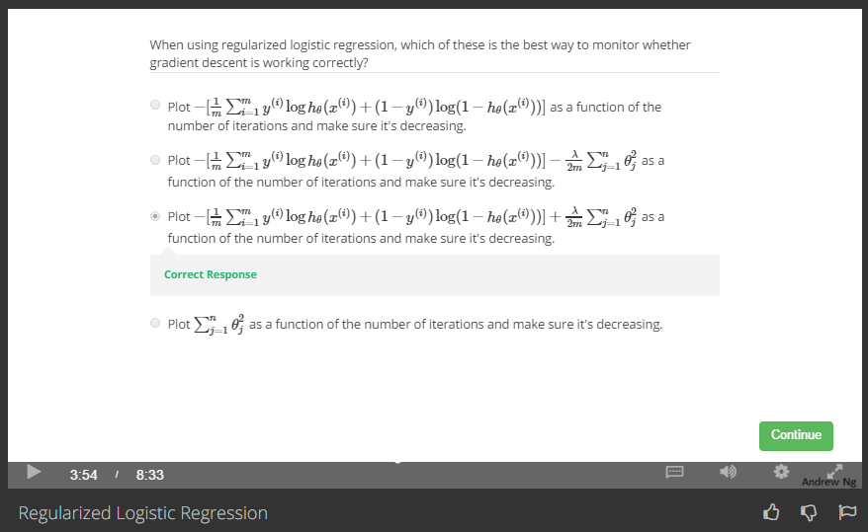

Make sure the [cost function J(θ) of logistic regression](https://share.coursera.org/wiki/index.php/ML:Logistic_Regression) decrease with iterations.

*J*(*θ*)=−1*m*∑*i*=1*m*[*y*(*i*)log(*hθ*(*x*(*i*)))+(1−*y*(*i*))log(1−*hθ*(*x*(*i*)))]